**Implementation of vehicle toll collection using GNSS Technologies**

**Submitted**

**By**

**MAVILLA AKASH – BU21EECE0100206  
KHATEEB GOUISYA – BU21EECE0100467**

**SANA SOWMYA – BU21EECE0100398**

**Under the Guidance of**

**(Dr. Nagarjuna Telagam )**

**(Duration: Date/Month/Year to Date/Month/Year)**



**Department of Electrical, Electronics and Communication Engineering**

**GITAM School of Technology**

**GITAM**

**(DEEMED TO BE UNIVERSITY)**

**(Estd. u/s 3 of the UGC Act 1956)**

**NH 207, Nagadenehalli, Doddaballapur taluk, Bengaluru-561203 Karnataka, INDIA.**

**DECLARATION**

**I/We declare that the project work contained in this report is original and that I did it under the guidance of my project guide.**

**Name:**

**Date: Signature of the Student**

**Department of Electrical, Electronics and Communication Engineering**

**GITAM School of Technology, Bengaluru-561203**

**CERTIFICATE**

**This is to certify that (Student Name) bearing (Regd. No.:) has satisfactorily completed the Mini Project Entitled in partial fulfillment of the requirements as prescribed by the University for the semester, Bachelor of Technology in “Electrical, Electronics and Communication Engineering” and submitted this report during the academic year 2024-2025.**

**[Signature of the Guide] [Signature of HOD]**

**Table of contents**

**Chapter 1: Introduction 1**

1.1 Overview of the Problem Statement 1

1.2 Objectives and Goals 1

**Chapter 2: Literature Review 2**

**Chapter 3: Strategic Analysis and Problem Definition 3**

3.1 SWOT Analysis 3

3.2 Project Plan - GANTT Chart 3

3.3 Refinement of Problem Statement 3

**Chapter 4: Methodology 4**

4.1 Description of the approach 4

4.2 Tools and Techniques Utilized 4

4.3 Design Considerations 4

**Chapter 5: Implementation 5**

5.1 Description of how the project was executed 5

5.2 Challenges faced and solutions implemented 5

**Chapter 6:Results 6**

6.1 outcomes 6

6.2 Interpretation of Results 6

6.3 Comparison with existing literature or technologies 6

**Chapter 7: Conclusion 7**

**Chapter 8: Future Work 8**

Here write Suggestions for further research or development Potential improvements or extensions 8

**References 9**

# Chapter 1: Introduction

Toll collection systems play a vital role in modern transportation infrastructure, facilitating revenue generation for road maintenance and development. Traditional toll collection methods, such as manual toll booths and RFID-based systems, often suffer from drawbacks including congestion, high operational costs, and inefficiencies in tracking vehicle movement. To address these challenges, the adoption of Global Navigation Satellite System (GNSS)-based toll collection technology has emerged as a promising solution. GNSS technology enables real-time tracking of vehicles, allowing for automatic toll fee calculation based on the distance traveled. Unlike conventional methods, which rely on physical toll booths or dedicated short-range communication (DSRC), GNSS-based tolling eliminates the need for infrastructure-heavy setups, making it a scalable and efficient approach for modern road networks. The motivation behind this project stems from the need to enhance toll collection accuracy, reduce traffic congestion, and enable seamless transactions, thereby contributing to a smarter transportation ecosystem. This project focuses on the implementation of a GNSS-based vehicle toll collection system using MATLAB. The primary objective is to develop an efficient, automated tolling mechanism that utilizes GNSS data for vehicle tracking, toll calculation, and seamless payment processing. By integrating map-matching techniques and on-board units (OBUs), the proposed system aims to enhance toll collection accuracy and streamline the payment process. The system operates by leveraging GNSS technology to track vehicle movements and determine toll charges dynamically based on the distance traveled. Through the use of MATLAB, the project implements algorithms that process GNSS data, apply map-matching techniques, and automate toll deductions. This approach not only improves operational efficiency but also reduces the reliance on physical toll infrastructure. The core objective of this project is to design and implement a GNSS-based vehicle toll collection system that ensures efficient, accurate, and automated toll fee processing. The major goals include real-time vehicle tracking using GNSS data, implementing a map-matching technique to calculate toll charges dynamically, enabling automatic toll deduction through integrated OBUs, minimizing delays caused by traditional toll booths by adopting a contactless tolling approach, enhancing the accuracy and efficiency of toll fee computation and transactions, and ensuring the system’s scalability for large-scale implementation and future technological advancements. Several research studies and existing implementations have explored the use of GNSS technology for toll.

Collection, including studies that highlight the advantages of GNSS-based tolling over conventional methods, emphasizing efficiency, scalability, and potential privacy challenges. Other studies discuss the use of satellite tracking for dynamic pricing models, ensuring transparency and cost-effectiveness in tolling systems, while some propose an automatic toll deduction system using GNSS for real-time transaction processing, reducing operational bottlenecks. The insights from these studies serve as a foundation for designing a robust and efficient GNSS-based toll collection system, integrating advanced algorithms for accurate and seamless toll transactions. The system architecture consists of several key components, including a GNSS data processing module that captures real-time vehicle location data, a map-matching algorithm that processes GNSS coordinates to determine tollable road sections, on-board unit (OBU) integration to facilitate seamless toll deduction and transaction processing, a toll charger system that computes toll fees based on distance traveled and predefined pricing models, and a payment gateway that ensures automatic deduction of toll charges via digital payment methods. The architectural framework enables seamless integration of GNSS technology with MATLAB-based tolling algorithms, ensuring high accuracy and efficiency in toll fee processing. The project implementation follows an iterative approach, involving system development where MATLAB-based toll calculation algorithms are designed and implemented, testing and refinement through multiple testing phases to optimize accuracy and efficiency, and performance evaluation through real-world scenarios and simulations. Preliminary results indicate significant improvements in toll collection accuracy, reduced traffic congestion, and enhanced user experience, demonstrating the potential of GNSS-based tolling systems for large-scale adoption. This project successfully implements a GNSS-based toll collection system, leveraging MATLAB for real-time vehicle tracking and automated toll deduction. The system enhances operational efficiency, minimizes congestion, and ensures seamless transactions, making it a viable alternative to traditional tolling methods. Future enhancements include implementing the system on physical GNSS devices for real-world applications, optimizing algorithms for improved precision and faster processing, and strengthening data privacy measures while ensuring scalability for broader adoption. By advancing GNSS-based tolling technology, this project contributes to the evolution of intelligent transportation systems, paving the way for more efficient and user-friendly road networks.

## Overview of the problem statement

The existing toll collection methods, including manual toll booths and RFID-based systems, have several limitations that contribute to inefficiencies in modern transportation systems. Traditional toll booths require vehicles to stop or slow down for payment, causing significant traffic congestion, increased travel time, and fuel wastage. Additionally, manual toll collection is prone to human errors, delays, and operational costs associated with staffing and maintenance. RFID-based tolling systems, while an improvement, still requires dedicated infrastructure such as gantries and RFID readers, making scalability and cost-effectiveness a challenge. Furthermore, these systems often face technical glitches, unauthorized vehicle access, and inconsistent toll fee deductions, leading to disputes and inefficiencies in revenue collection. The rise in vehicle population and increasing traffic density on highways further exacerbate these problems, highlighting the need for a more efficient, automated, and scalable solution.

A GNSS-based toll collection system provides a viable alternative by utilizing satellite-based vehicle tracking to calculate toll charges dynamically based on the distance traveled. Unlike conventional methods, this system eliminates the need for physical toll booths or RFID checkpoints, allowing for a seamless and contactless tolling experience. The core problem being addressed is the inefficiency and inconvenience associated with traditional toll collection, which contributes to traffic congestion, increased operational costs, and inaccuracies in toll computation. Additionally, manual toll collection methods increase the likelihood of revenue leakage due to errors, fraud, and system inefficiencies. The primary objective of this project is to design and implement a GNSS-based toll collection system that ensures accurate, automated, and efficient toll fee processing without disrupting the flow of traffic.

One of the critical challenges in developing a GNSS-based tolling system is ensuring accurate and real-time vehicle tracking. Factors such as signal loss in tunnels, multipath errors in urban areas, and GPS drift can impact the precision of location data, potentially affecting toll fee calculations. Implementing advanced error correction techniques and integrating robust map-matching algorithms can help mitigate these challenges. Another key consideration is the security and privacy of user data, as a GNSS-based system involves continuous tracking of vehicle movements. Addressing data protection measures, encryption techniques, and compliance with legal regulations is essential to ensure secure and privacy-preserving toll transactions.

Furthermore, integrating GNSS-based tolling with existing transportation infrastructure poses technical and logistical challenges. The system must be compatible with various vehicle types, ensure interoperability with payment gateways, and offer a user-friendly interface for motorists. Scalability is another concern, as the solution should be adaptable for large-scale implementation across multiple highways and urban road networks. The project aims to develop an efficient, robust, and scalable GNSS-based toll collection system using MATLAB, focusing on real-time vehicle tracking, dynamic toll computation, and seamless digital payment processing.

The need for an advanced tolling system is further emphasized by the increasing demand for smart transportation solutions in urban and highway environments. As governments and transportation authorities seek to improve road efficiency and revenue collection, a GNSS-based toll collection system presents a forward-looking approach that aligns with the objectives of intelligent transportation systems (ITS). This project contributes to the ongoing efforts to modernize tolling mechanisms, offering a contactless, automated, and transparent solution that enhances overall transportation efficiency. By addressing the existing challenges associated with traditional toll collection, the proposed GNSS-based system aims to create a smarter, more efficient, and hassle-free tolling experience for commuters while optimizing revenue management for toll authorities.

## 1.2 Objectives and Goals

Main Goals

1. Implement map-matching for toll calculation using GNSS data.

2. Integrate GNSS Lanes and Onboard Units (OBU) with the Toll Charger system.

Additional Goals

• **Enhance Security and Privacy Measures** – Implement robust encryption and authentication mechanisms to protect GNSS toll data, ensuring secure transactions and preventing unauthorized access.

• **Optimize System Scalability and Performance** – Improve the system’s efficiency for large-scale deployment by reducing processing latency, enhancing GNSS signal accuracy, and integrating cloud-based data management for real-time toll processing.

# Chapter 2: Literature Review

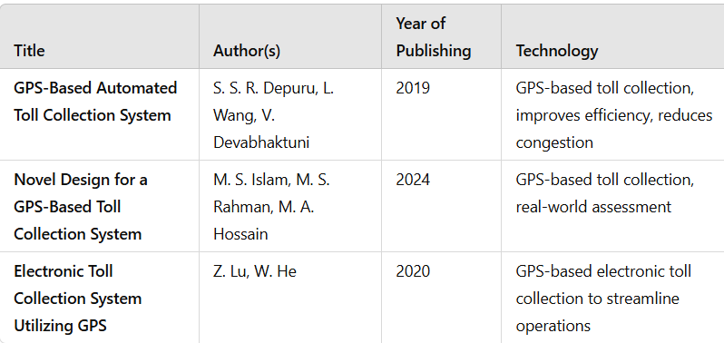

Reference:

* GNSS-Based Tolling: The Future of Road Charging Systems (2019)In short: Proposes toll collection using GNSS to charge vehicles by distance traveled, replacing toll booths. Highlights efficiency, scalability, and addresses signal and privacy issues.
* An Integrated GNSS Approach for Sustainable Toll Collection and Traffic Optimization (2024)In short: Uses GNSS for toll collection via satellite tracking, enabling dynamic pricing and transparency; addresses cost and privacy challenges.
* Automatic Toll Collection using GNSS (2020)In short: Proposes a GNSS-based system for automatic toll deduction and real-time transaction updates, improving toll efficiency

# Chapter 3: Strategic Analysis and Problem Definition

Strategic Analysis and Problem Definition focus on evaluating the key factors influencing the development and implementing of a GNSS-based toll collection system. The strategic analysis begins by identifying the need for a more efficient, scalable, and transparent tolling mechanism to replace conventional toll booths, which often cause congestion and delays. The adoption of GNSS-based tolling offers a dynamic pricing model that accounts for real-time traffic conditions, distance traveled, and vehicle type, ensuring a fair and flexible toll structure. However, challenges such as accuracy in location tracking, privacy concerns, and system integration complexities must be addressed. Furthermore, the implementation requires collaboration between government authorities, private stakeholders, and technology providers to establish standardized protocols and ensure seamless interoperability.

A major concern in GNSS-based tolling is the risk of signal interference, which can affect accuracy and lead to discrepancies in toll calculations. Additionally, cybersecurity threats pose a risk to data integrity and user privacy, requiring robust encryption and security measures. The problem definition revolves around mitigating these challenges while optimizing the system for maximum efficiency and cost-effectiveness. Addressing public acceptance is another critical factor, as users may be hesitant to transition from traditional tolling systems to a satellite-based model. Strategic solutions include extensive awareness campaigns, incentives for early adopters, and pilot programs to demonstrate the effectiveness of the technology. The integration of GNSS lanes and Onboard Units (OBUs) into the toll charging system must be meticulously planned to ensure real-time transaction processing, minimal errors, and a user-friendly experience. Moreover, regulatory frameworks must be established to govern data collection, usage, and storage, safeguarding consumer rights and ensuring compliance with legal standards. The chapter also explores additional goals beyond implementation, such as leveraging GNSS data for traffic optimization and urban planning.

By analyzing vehicle movement patterns, authorities can make informed decisions regarding road infrastructure improvements, congestion management, and environmental impact reduction. Another goal is the integration of GNSS-based tolling with emerging technologies such as connected vehicles and autonomous driving systems, paving the way for a more intelligent transportation ecosystem. In conclusion, this chapter highlights the strategic considerations and problem areas in GNSS-based toll collection, emphasizing the need for a balanced approach that combines technological advancements, regulatory measures, and public engagement to achieve a seamless, efficient, and widely accepted tolling solution.

## 3.1 **SWOT Analysis**

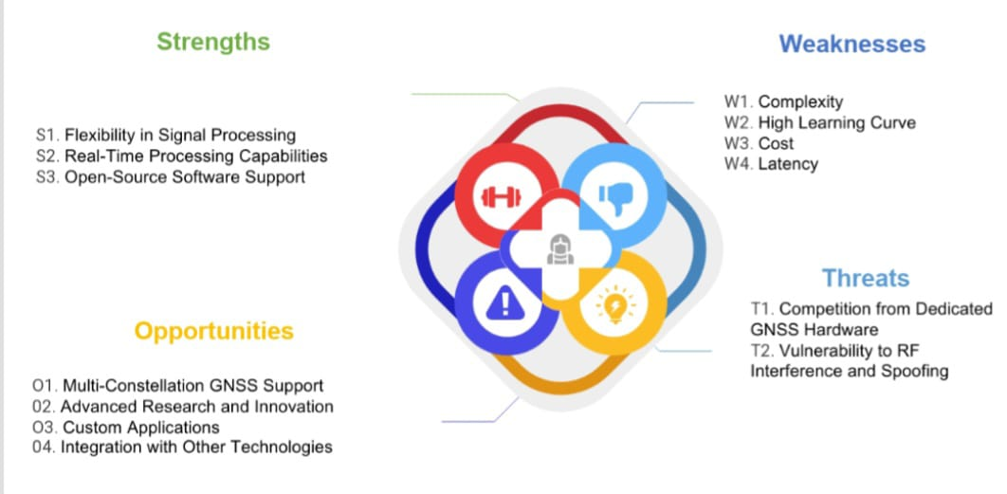

### 3.2 **Project Plan - GANTT Chart**

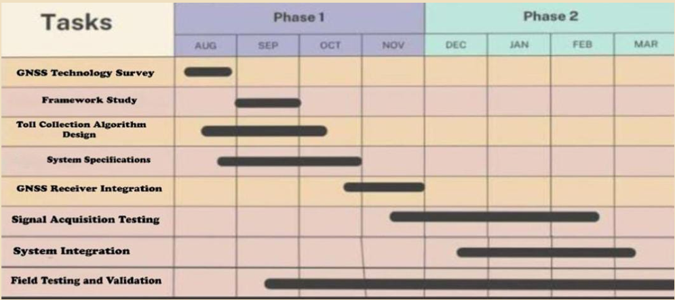

##### 3.3 **Refinement of problem statement**

The implementation of a GNSS-based toll collection system presents a transformative shift in road pricing mechanisms, addressing inefficiencies in conventional toll booths while introducing new challenges that require strategic resolution. The core problem revolves around ensuring seamless integration of GNSS technology into the tolling infrastructure while maintaining accuracy, security, public acceptance, and regulatory compliance. Conventional toll collection methods, such as manual toll booths and RFID-based electronic toll collection (ETC) systems, often lead to congestion, delays, and high operational costs. A GNSS-based system eliminates the need for physical toll barriers, enabling real-time, distance-based pricing that enhances flexibility and fairness in tolling. However, this transition comes with several challenges that need to be systematically addressed.

One of the primary challenges is the accuracy and reliability of location tracking. GNSS signals are susceptible to interference from tunnels, urban canyons, and weather conditions, which can lead to incorrect toll calculations. Ensuring high-precision positioning through multi-constellation GNSS, augmentation systems, and advanced algorithms is essential to mitigate this issue. Additionally, cybersecurity concerns pose a significant threat to the integrity of the system. Unauthorized access, data breaches, and fraudulent activities could compromise toll transactions, leading to financial losses and reduced trust in the system. Implementing robust encryption protocols, secure data storage, and continuous monitoring mechanisms are necessary to counter cybersecurity risks.

### **Chapter 4: Methodology**

• **Component Selection:** Identify and select essential components required for implementing the GNSS-based toll collection system. This includes GNSS modules for location tracking, microcontrollers for processing data, communication interfaces (such as GSM, Wi-Fi, or Bluetooth) for data transmission, Onboard Units (OBUs) for vehicles, and secure servers for data management. The selection process considers factors such as accuracy, power efficiency, cost-effectiveness, and compatibility with existing infrastructure.

• **System Design and Simulation:** Develop a system architecture that outlines the interaction between various components. Design a schematic representation of the system, ensuring that GNSS modules are accurately interfaced with OBUs and backend servers. Simulate the designed system using software tools to verify its functionality before implementation. Ensure proper power management, signal processing, and data security protocols are in place to minimize errors and improve efficiency.

• **Component Integration:** Assemble the selected hardware components to build a functional prototype. Ensure that the GNSS module is correctly integrated with the microcontroller, communication interfaces, and onboard processing units. Establish secure data transmission between vehicles and tolling servers. Proper hardware placement, soldering, and signal routing must be followed to optimize performance and reduce interference.

• **Software Development and Programming:** Develop firmware and software to control system operations. Implement microcontroller programming for real-time location tracking, toll calculation, data encryption, and secure communication. Design an intuitive user interface for toll operators and vehicle owners to access and manage their accounts. Ensure compatibility with cloud-based storage for data logging and retrieval.

• **Testing and Calibration:** Conduct extensive testing of the system in various real-world conditions, such as highways, urban roads, and tunnels. Calibrate the GNSS tracking accuracy by comparing recorded data with reference locations. Test the communication reliability between vehicles and tolling servers. Perform security testing to identify potential vulnerabilities in data transmission and implement necessary encryption measures.

• **Data Collection and Analysis:** Deploy the system in a controlled environment to collect tolling data under different driving conditions. Record toll transactions, analyze accuracy, and measure latency in data transmission. Use analytical tools to evaluate system performance and identify areas for improvement. Assess public response and operational feasibility to refine the system for large-scale implementation.

### **4.1 Description of the Approach**

The project focuses on designing and developing a GNSS-based toll collection system to improve efficiency, accuracy, and scalability in vehicle tolling. This system integrates GNSS modules, microcontrollers, communication interfaces, and secure data management to enable automatic toll deduction based on real-time vehicle tracking. By eliminating physical toll booths, the project aims to reduce congestion, enhance toll collection accuracy, and provide seamless transactions. The approach involves hardware and software integration to ensure secure and efficient toll processing.

### **4.2 Tools and Techniques Utilized**

• **GNSS Modules:** High-precision GNSS receivers for accurate vehicle location tracking.  
• **Microcontrollers:** Embedded controllers for processing GNSS data and managing toll calculations.  
• **Communication Interfaces:** GSM, Wi-Fi, or Bluetooth modules for secure data transmission.  
• **Onboard Units (OBUs):** In-vehicle devices for real-time toll processing and communication with the central tolling system.  
• **Secure Data Management:** Cloud-based storage and encryption protocols to ensure data integrity and privacy.

### **4.3 Design Considerations**

Several design considerations are crucial for the successful development of the GNSS-based toll collection system:  
• **Accuracy:** Ensuring precise vehicle tracking using multi-constellation GNSS and error correction techniques.  
• **System Integration:** Seamless connectivity between GNSS modules, OBUs, microcontrollers, and tolling servers.  
• **Data Security:** Implementing encryption and authentication mechanisms to protect user data and prevent fraud.  
• **Scalability:** Designing the system to accommodate a high number of vehicles and expand across different toll networks.  
• **User Experience:** Ensuring an intuitive and user-friendly interface for both toll operators and drivers.

### **Chapter 5: Implementation**

#### **5.1 Project Overview**

• **Main Goals**

* Develop a GNSS-based toll collection system for real-time, automated tolling.
* Improve accuracy, efficiency, and scalability while reducing congestion at toll booths.

• **Hardware and Software Design**

* **PCB Design:** Develop a custom PCB integrating GNSS modules, microcontrollers, and communication interfaces.
* **User Interface:** Design a user-friendly interface for toll monitoring and data management.
* **Vehicle Onboard Units (OBUs):** Ensure smooth interaction between OBUs and the central tolling system.

• **Additional Goals**

* **Wireless Data Transmission:** Enable real-time communication between vehicles and tolling servers.
* **Secure Data Management:** Implement encryption and authentication mechanisms to protect user data.

#### **5.2 Design and Development Process**

• **PCB Design**

* Designing a custom PCB using EasyEDA, Altium, and Eagle software.
* Modifying the PCB layout based on system calibration and integration requirements.

• **GNSS Module Integration**

* Selecting a high-precision GNSS receiver to track vehicle movement accurately.
* Developing a readout circuit for real-time location data processing.

• **Microcontrollers**

* Selecting energy-efficient microcontrollers to enhance system accuracy and efficiency.
* Utilizing low-power operation modes to optimize power consumption.

• **Power Management System**

* Implementing voltage regulation techniques for stable power distribution.
* Ensuring efficient power utilization for prolonged system operation.

• **Wireless Communication Module**

* Enabling real-time data transmission to reduce processing errors.
* Ensuring reliable communication through GSM, Wi-Fi, or MQTT protocols.

• **Data Analysis and Processing**

* Collecting real-time tolling data for accuracy validation.
* Analyzing data trends for system optimization.

#### **5.3 Prototyping**

##### **5.3.1 Circuit Design**

• **Microcontroller**

* The microcontroller serves as the core processing unit, handling GNSS data acquisition, toll calculation, and secure communication.
* It interfaces with the GNSS module and manages power consumption to ensure efficient operation.

• **Power Management System**

* A stable power supply is ensured using a voltage regulator to maintain consistent performance.
* Backup power sources, such as battery integration, are considered for uninterrupted functionality.

• **Readout Circuit**

* A control amplifier and voltage converters ensure accurate GNSS signal processing.
* This circuit maintains signal integrity for error-free tolling operations.

• **User Interface (GUI)**

* A dashboard is designed for toll monitoring and management.
* Using **Node-RED** for a visual dashboard and **MQTT protocol** for secure data transfer from the system to the server.

##### **5.3.2 PCB Design**

• **Design Considerations**

* **Signal Integrity:** Optimizing PCB layout to minimize interference.
* **Component Placement:** Ensuring efficient power utilization and improved performance.
* **Durability:** Using robust materials for long-term field deployment.

• **Methodology**

* **Circuit Simulation:** Simulating the design to test signal processing and real-time data transmission.
* **Testing and Prototyping:** Evaluating system performance before full-scale implementation.

#### **5.4 Testing and Validation**

##### **5.4.1 Testing Procedures**

* The system is tested with real-world GNSS data to assess accuracy, response times, and reliability.
* Environmental conditions are analyzed to measure the impact on GNSS signal quality.
* Data security mechanisms are tested to ensure encryption and privacy protection.

##### **5.4.2 Results Analysis**

* **Accuracy of GNSS Data:** The system demonstrates precise toll calculations with minimal error.
* **Power Efficiency:** Optimization techniques result in low power consumption, enabling prolonged operation.
* **Latency Metrics:** Real-time toll processing ensures seamless transactions with minimal delay.

#### **5.5 Execution of the Project**

1. **Objective Definition:** Develop an efficient, automated GNSS-based toll collection system.
2. **Research and Literature Review:** Study existing tolling solutions and identify technical gaps.
3. **Circuit Design and Simulation:** Model the system using specialized tools before hardware development.
4. **PCB Design:** Implement an optimized layout for minimal signal interference and power consumption.
5. **Component Integration:** Assemble GNSS modules, microcontrollers, and communication interfaces onto the PCB.
6. **Microcontroller Programming:** Develop firmware for data acquisition, processing, and secure communication.
7. **Calibration and Testing:** Validate GNSS accuracy and tolling algorithms against reference data.
8. **Data Collection and Analysis:** Evaluate real-time toll transactions to refine system performance.
9. **Iteration and Optimization:** Implement improvements based on testing results and stakeholder feedback.
10. **Future Work Planning:** Explore further enhancements, such as AI-driven toll optimization and cloud-based analytics.

**5.6 Challenges Faced and Solutions Implemented**

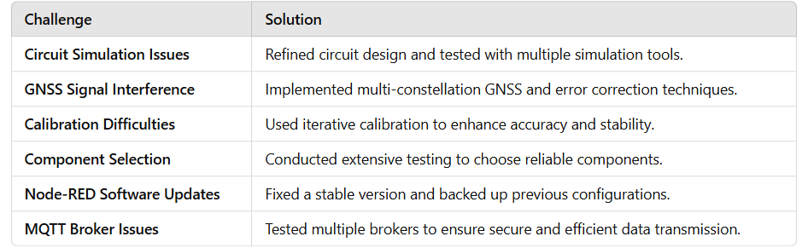

### **Chapter 6: Results**

#### **6.1 Outcomes**

• The project successfully developed a customized GNSS-based toll collection system, integrating key components such as GNSS modules, microcontrollers, onboard units (OBUs), power management systems, and wireless communication modules. The system demonstrated reliable real-time toll processing, reducing congestion and improving transaction accuracy.

#### **6.2 Interpretation of Results**

• Testing revealed that the GNSS-based system consistently provided accurate vehicle location tracking and seamless toll transactions, validating its effectiveness as an automated tolling solution. Additionally, the power management system ensured efficient energy consumption, enabling prolonged operation and reducing maintenance costs.

#### **6.3 Comparison with Existing Technologies**

• Compared to traditional RFID-based and manual toll collection methods, this project emphasizes automation, scalability, and cost-efficiency. Unlike existing systems that rely on physical infrastructure such as toll booths, the GNSS-based approach eliminates bottlenecks, minimizes human intervention, and enhances transparency in toll transactions.

### **Chapter 7: Conclusion**

The project focused on the design and development of a **GNSS-based toll collection system**, aiming to create an automated, real-time tolling solution that integrates multiple subsystems, including **GNSS tracking modules, microcontrollers, power management systems, and secure data communication protocols**. By leveraging satellite positioning technology, the system enables **seamless toll transactions** without the need for physical toll booths, reducing congestion and improving road efficiency. The primary objectives included enhancing **tolling accuracy, ensuring power efficiency, and enabling robust data transmission** for secure toll processing. The project emphasized thorough testing and system calibration to optimize performance and ensure reliability across diverse environmental conditions. Future work will focus on **real-world deployment**, further improving **data security measures**, **enhancing interoperability with existing tolling infrastructure**, and **integrating advanced analytics for traffic management and dynamic pricing strategies**.

### **Chapter 8: Future Work**

• **System Scalability and Deployment:** Future efforts will focus on expanding the GNSS-based tolling system across **multiple regions and highways**, ensuring compatibility with various government tolling policies and existing toll networks. Additional testing will be conducted to refine **multi-vehicle tracking accuracy** and **real-time transaction processing**.

• **Enhanced Data Security Measures:** Strengthening **encryption protocols and authentication mechanisms** will be prioritized to prevent potential cyber threats. Implementing **blockchain-based toll transaction records** will ensure transparency and security in toll payments.

• **Improved Wireless Communication for Real-Time Processing:** Future research will explore **5G, LoRa, or improved MQTT protocols** to enable high-speed, low-latency communication between **vehicles, toll servers, and cloud storage platforms**, ensuring seamless toll deduction without connectivity disruptions.

• **Graphical User Interface (GUI) Enhancement:** The development of a more **intuitive and user-friendly dashboard** will be a significant focus. Future iterations will **improve real-time tracking visualization**, allow users to **monitor toll history**, and incorporate **customizable alerts for toll charges and payment statuses**.

• **Advanced Data Analysis for Traffic Optimization:** Implementing **machine learning algorithms** to analyze vehicle movement patterns and predict congestion trends will be a key area of improvement. These insights can be used to enable **dynamic toll pricing**, reducing traffic congestion during peak hours and optimizing toll revenue collection.

**THE END**